BASKETBALL PRACTICE LOCATIONS

Shannon Forest Presbyterian Church
830 Garlington Road
Greenville, SC 29615-5440

Shannon Forest Christian School
829 Garlington Road
Greenville, SC 29615-5440

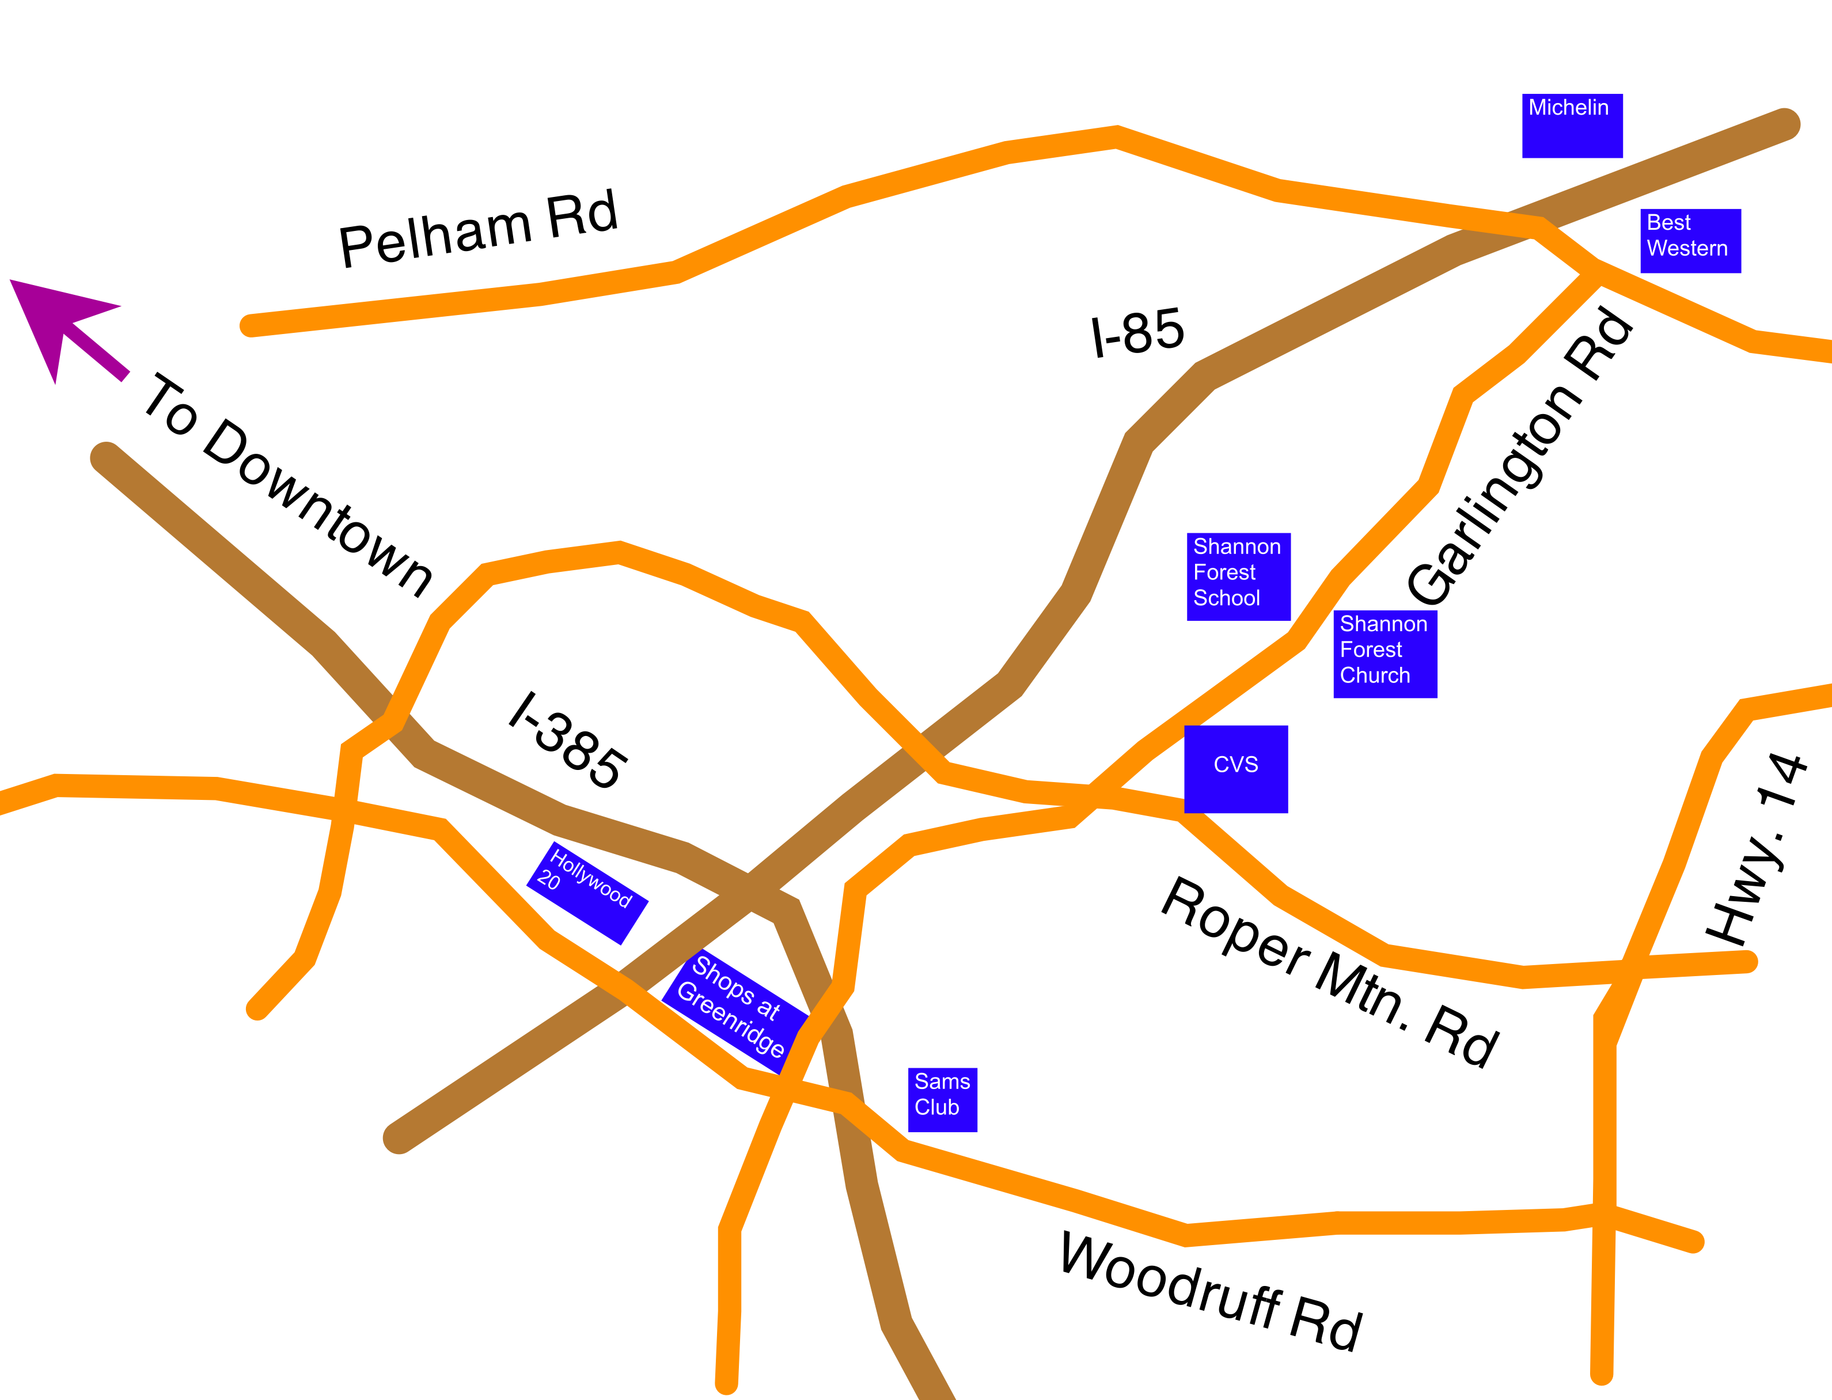

Monday, Thursday Friday practices are held at the church gym.

Wednesday practics are held at the school gym.

Please be respectful of the facilities, the teams practicing on the other half of the court and other teams coming in before or after your practice.

